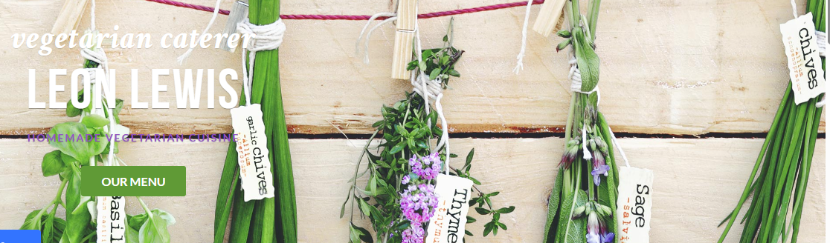
SAMPLE MENU for FRIDAY 1st May - to be confirmed.
Leon’s menus are custom-made due to the personal preferences of the person catered for. Allergies, lactose-intolerant, gluten-free and vegan menus can be available on request.
However, a general menu using recipes from Leon’s books can include a variety of dishes such as the following:
NETTLE AND ONION QUICHE MUSHROOM AND CASHEW NUT ROAST
SPINACH AND LENTIL FILO PIE QUICHE NICOISE
WILD RICE SALAD PUY LENTIL SALAD TABBOULI SALAD
SINY’ET BEDINGAL (EGYPTIAN MARINATED AUBERGINES)
CAPONATA
WHITE CHOCOLATE CHEESECAKE TO DIE FOR WITH BLACKBERRIES IN CRÈME DE CASSIS
PECAN PIE
APRICOT BAKLAVA
RICH GLUTEN FREE CHOCOLATE CAKE

In 2025, Leon served his delicious food at several music, folk and dance festivals, including:
A New Day, Chippenham, Glastonbury, Ely, Cropredy, New Forest and Warwick

WEBSITE: https://www.leonlewis.co.uk/

